Chat with Big Ed: Investigate answers

ncce.io/biged1

Questions | Your answers ▿
How do the following two blocks of code relate to each other?  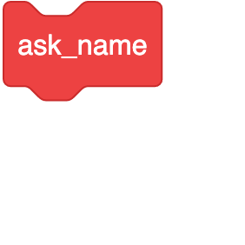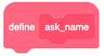 | The ask_name block will tell the program to run the code that is placed under the define ask_name.
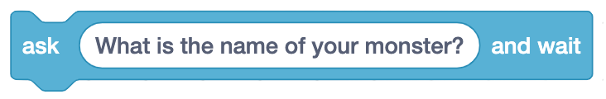  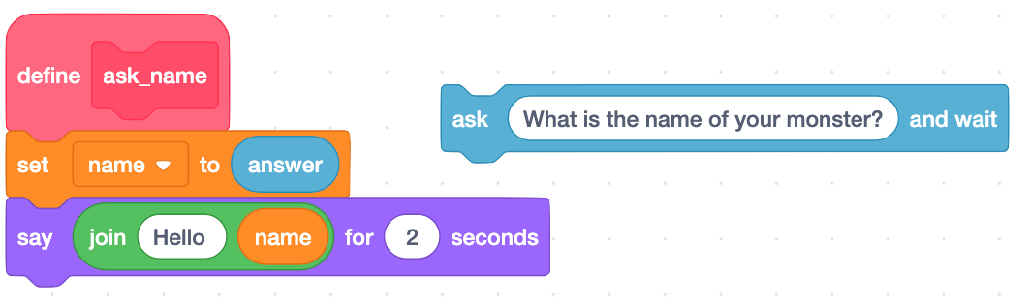  Temporarily remove the following block:  What has this changed about the program when you run it?  Why do you think this is? | Big Ed will now only say “Hello”.  As the question has not been asked, there is no “answer”.  The line “set name to answer” will now give name an empty value.
Below define ask_name, there are two variables being used. What are their names? | “answer” and “name”
Now place the ask what is your name and wait block back into the code, but place it after the set name to answer block:  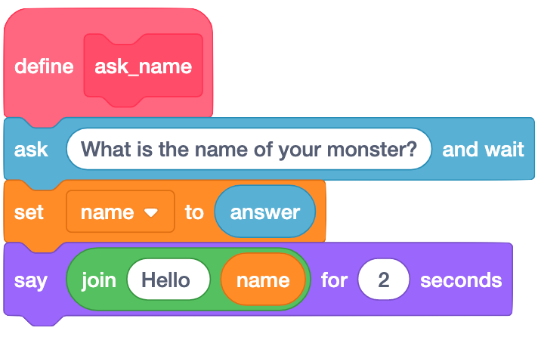  Why do you think it only says “Hello” and not “Hello” and the name you entered?  What can you learn from this? | It is because “name” is being linked to “answer” before the question is asked.  You must always set the value of a variable before you use it.

Resources are updated regularly — the latest version is available at: ncce.io/tcc.

This resource is licensed under the Open Government Licence, version 3. For more information on this licence, see ncce.io/ogl.

